Supplier guidance on the TfS Audit Program
In order to facilitate a smooth execution of the TfS Audit Program, the following information are provided for your guidance:

- Official invitation letter of [TfS member’s] to participate in a TfS Audit
- Table with next steps to be taken
- Summary of the process of the TfS Audit Program
- TfS Supplier Confirmation Form to be completed and signed with useful information about the TfS Audit Program

We are looking forward to receiving your completed and signed “TfS Audit – Supplier Confirmation Form” (see below).
In case of questions, please do not hesitate to contact [TfS member contact (buyer)] or the TfS Office (helpdesk@tfs-initiative.com).
For additional information about the Together for Sustainability (TfS) Initiative and the TfS Audit Program, you may also visit the TfS website at www.tfs-initiative.com.

Kind regards,
[TfS member contact]

- Table with next steps to be taken
This table summarizes the next steps we kindly ask you to take.

Next steps | Requested due date
- Appoint a person within your organization responsible for taking care of the next steps and arranging the TfS Audit. | 2 weeks  after invitation date
- With [TfS member], define and confirm the scope of the TfS Audit (please consider existing audit schemes, see section 3) in the Supplier Confirmation Form provided below. In case requested, decide on whether to accept a TfS Witness Audit by [TfS member].
- Contact and contract one of TfS’ preselected Audit Firms (for contact details click here) and sign the TfS Data Sharing Agreement: | 2 weeks  after invitation date
- Set the TfS Audit date.
- Complete and sign the TfS Supplier Confirmation Form (see below), and send it to [TfS member] as well as the TfS Office (helpdesk@tfs-initiative.com).
- Prepare for the TfS Audit (see specifics below in the TfS Supplier Confirmation Form) and have the TfS Audit executed. | before  TfS Audit

- Summary of the process of TfS Audit Program
These diagrams summarize the process steps involved in the initiation and follow-up of TfS Audits.

TFS AUDIT PREPARATION PROCESS:
Supplier takes the following steps:
- Familiarizes with the TfS initiative
- Agrees on scope & TfS Witness Audit y/n
- Contracts TfS’ preselected audit firm
- Signs TfS Data Sharing Agreement
- Sets the TfS Audit date
- Signs TfS Supplier Confirmation Form
TfS Audit execution
TfS member invites supplier
Supplier prepares for TfS Audit

TFS FOLLOW-UP ACTIONS AND TIMELINES:
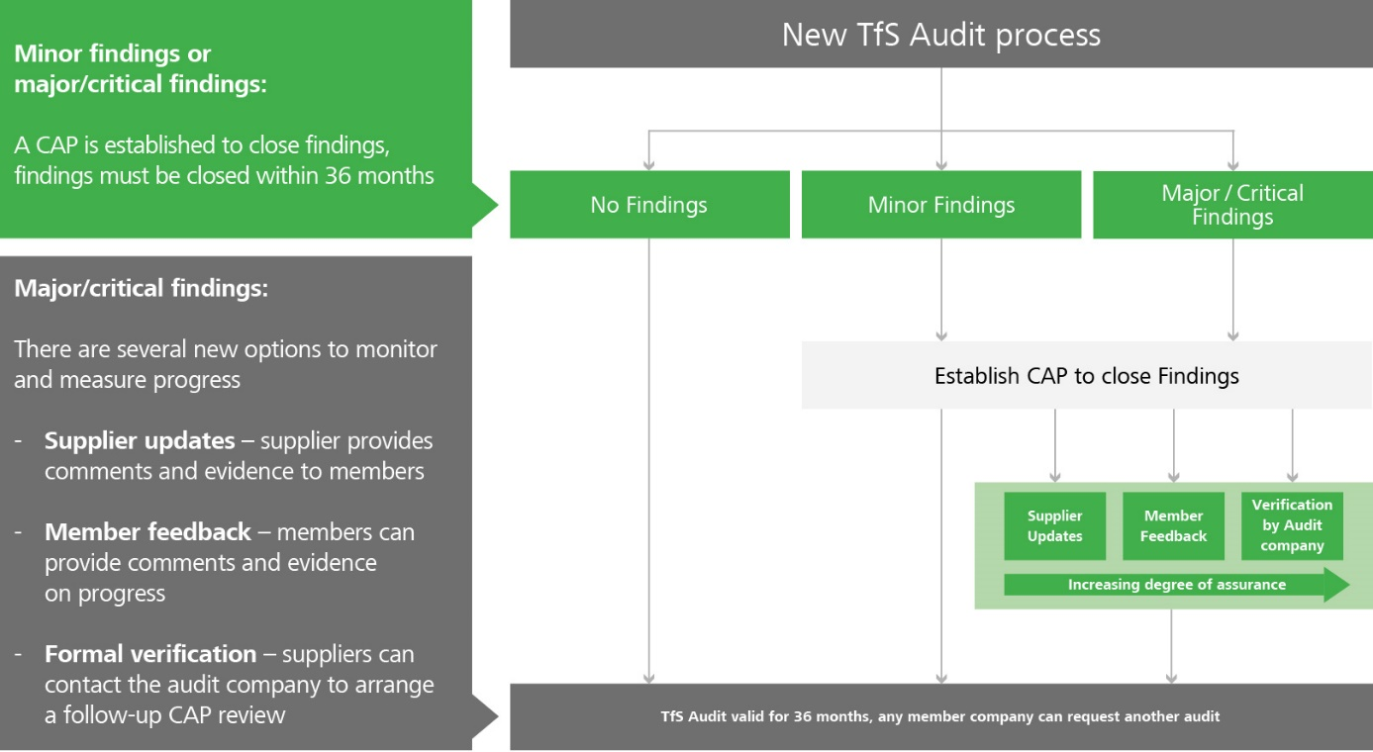

TfS Supplier Confirmation Form
TfS Supplier ID
[provided in email by TfS Office when ownership is granted]

 | 1. Supplier Details
 | Company name (legal entity) |  |  | Supplier contact name for contact with [TfS member contact]  (Supplier contact 1 – commercial contact)
 | Company site name (if different from above) |  |  | Function/Job title
 | Ultimate parent company name |  |  | Contact phone number
 | DUNS number (9-digit code) |  |  | Contact email
 | Tax number |  |  | Supplier contact name responsible for  TfS Audit execution  (Supplier contact 2)
 | Site address (street, number)
 |  |  |  | Function/Job title
 | Site state / province |  |  | Contact phone number
 | Site country |  |  | Contact email
 | 2. TfS Audit Information
 |  |  |  |  |  |  | Content was seen/read:
 | Video: TfS Short Introduction (2 min) |  |  |  |  | Web -Link 1 | ☐
 | TfS Brochure |  |  |  |  | Web -Link 2 | ☐
 | Frequently Asked Questions TfS |  |  |  |  | Web -Link 3 | ☐
 | General description TfS Audit Program |  |  |  |  | Web -Link 4 | ☐
 | Detailed description of TfS Third Party Audit Program – Version 3.1 |  |  |  |  | Web -Link 5 | ☐ (voluntary)
 | Online training modules
 | - Module 1: Raising awareness about sustainable sourcing (8 min) |  |  |  |  | Web –Link 6 | ☐
 | - Module 2: TfS Introduction (8 min) |  |  |  |  | Web -Link 7 | ☐
 | - Module 4: Fit for audit (10 min) |  |  |  |  | Web -Link 8 | ☐
 | 3. TfS Audit Preparation
 | TfS Audit Scope  Please specify if different from site and take into account pre-existing RCMS/RC14001 and SQAS audits and fill the gray sections only if they apply: | Name and address of the facility to be audited:  Name of specific plant(s) to be audited:  Organizational unit of the plant(s) audited:  Miscellaneous (voluntary additional information):
 |  | TfS Short Audit Eligibility: Site* is in possession of a valid RCMS®/RC 14001® Certificate and the report are available for review.  Sites in US and Canada in possession of a valid Responsible Care (RC) certificate are eligible to conduct a shorter version of the TfS audit; please send the certificate and report for review to your requesting customer and the TfS Helpdesk for verification of eligibility.  *In the US and Canada |  |  |  |  | ☐ yes / ☐ no *
 |  | SQAS Assessment conducted after 01/04/2016:  Sites who have conducted an SQAS assessment module Transport Service and/or Warehouse (in Europe) are eligible for unilateral recognition by TfS. Please send the SQAS report to your requesting customer as well as this signed DSA |  |  |  |  | ☐ yes / ☐ no *
 | TfS Witness Audit will be conducted to improve the quality of the TfS Audit Program  The Witness Auditor will use a standardized TfS Witness Auditor checklist which will be consolidated by the TfS Office. |  |  |  |  |  | ☐ yes / ☐ no
 | All aspects with regard to TfS Audit Program preparation have been understood |  |  |  |  | Web-Link 9 | ☐ yes / ☐ no *
 | TfS audit firm selected from TfS’ list of preapproved ones and contractual terms agreed  The follow-up audit should be part of the negotiation when contracting for the initial audit. |  |  |  |  | Web –Link 10 | ☐ yes / ☐ no *
 | I have approached SGS and they answered me (if applicable) |  |  |  | ☐ in less than 3 days / ☐ in 3-7 days / ☐ in more than 7 days
 | I have approached Intertek and they answered me (if applicable) |  |  |  | ☐ in less than 3 days / ☐ in 3-7 days / ☐ in more than 7 days
 | I have approached DQS and they answered me (if applicable) |  |  |  | ☐ in less than 3 days / ☐ in 3-7 days / ☐ in more than 7 days
 | I have approached ERM and they answered me (if applicable) |  |  |  | ☐ in less than 3 days / ☐ in 3-7 days / ☐ in more than 7 days
 | Which TfS audit firm has been finally contracted for the execution of TfS Audit? |  |  |  |  | SGS / Intertek / DQS / ERM *
 | TfS Data Sharing Agreement (DSA) signed and sent to the TfS auditor |  |  |  |  |  | ☐ yes / ☐ no *
 | Which TfS Audit date(s) has/have been agreed on with the auditor? |  |  |  |  |  | DD/MM/YY
 |  |  |  |  |  |  | * Please cross out what is not applicable
 | 4. Supplier Confirmation
 | Hereby, we confirm that we will  execute a TfS Audit and have  conscientiously completed this form. | Signature of supplier (authorized to represent the company) |  |  |  |  | Date

